Single Posts (PART 3)

1. Your study process for trading is very important. Only focusing on theory and ignoring practice is a faulty approach – it can never make you truly successful.
Always take learning and applying the learned concepts side by side!

2. Which trading style is right for you?
DAY TRADING | SWING TRADING
Many trading opportunities | Less trading opportunities
Needs constant monitoring | Needs less attention – Set & Forget
Many small profits accumulate | Large profits but it take time
Trades closed within a day – quick in & out | Traders close after days or weeks – intermediate-term holding trades

3. Golden cross vs Death cross
Golden cross signifies a long-term bull market
Short PERIOD moving average

LONG PERIOD moving average

Death cross indicates a long-term bear market

LONG PERIOD moving average

Short PERIOD moving average

4. Cup and handle pattern
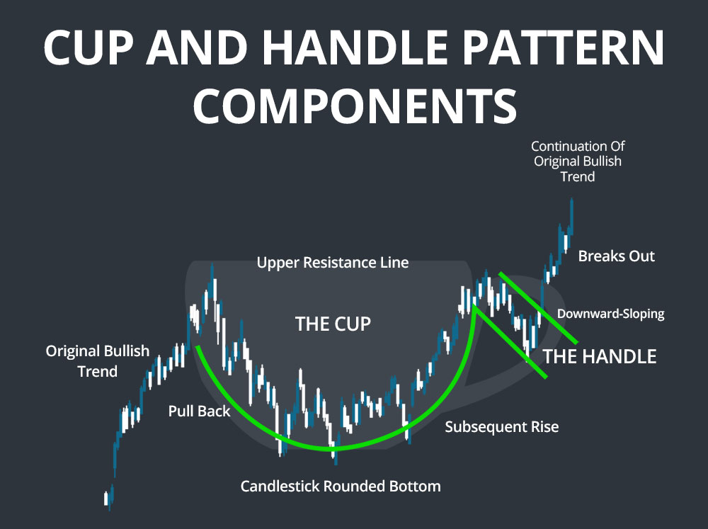

5. What do wick rejections mean?

Long upper wicks suggest that buyers pushed the price UP but sellers BEAT them and succeeded in bringing price down

Long lower wicks indicate that the sellers pushed the price DOWN but bulls BEAT the selling pressure and pushed the price UP.

6. Do you have REALISTIC trading goals?

UNREALISTIC | REALISTIC
I will not have any losses this week | I accept that losses are natural so I will focus on keeping the rewards higher than losses.
If I deposit a bigger amount, I can bag profits easily | No matter how big my capital is, I will have to stick to risk management
I will triple the account in 3 weeks | I will gradually and steadily build my returns and not take hasty decisions

7. There is NOT a “strategy that just works”. Every strategy can work DEPENDING on the quality of execution & risk management.

8. THREE high-impact news events
- NFP – measures the number of jobs added or lost in the US economy over the last month.
- CPI – provides inflation data
- Central bank rate decisions – indicates interest rate hikes and cuts.

9. How To Find a Strategy perfect for YOU
Your perfect strategy is the one that fits YOUR:
- Personality
- Lifestyle
- Work schedule
- Emotional intelligence

10.

YOUR Account size: $5,000

Other trader Account size: $50,000

Profit expectation: $1000 daily

Profit expectation: $1000 daily

11. How to perfectly utilize your 20’s
- Creating sources of passive income
- Learning to trade
- Prioritizing financial stability
- Planning long-term and securing your financial freedom

12. More money in your account CANNOT increase your success chances
If you cannot turn $1000 to $2000 (50% increase), you can also not turn $100,000 to $200,000.
Large capital DOES NOT make you a better trader.
So, FIRST, focus on improving your skills THEN, think about making a bigger account.

13. What is CONSOLIDATION
Consolidation refers to a market phase when price accumulates in a fixed range.
After a consolidation period, the price either breaks out upward or downward.
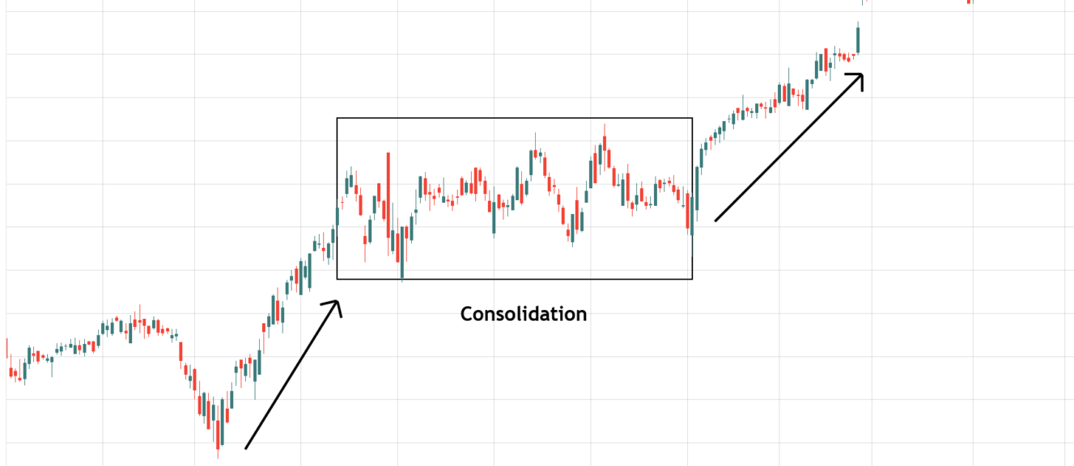
14. Why do 90% of traders fail?
- They do not thoroughly educate themselves about trading concepts and risks.
- They have unrealistic profit expectations.
- They trade based on their instincts rather than plans.
- They use excessive leverage and risk more than they can afford to lose.
15. Never be a SUPERFICIAL trader
- A real trader never trades on “hopes and wishes” but does what the market is telling
- A real trader has patience and understands that he does not need to force trades
- A real trader always re-examines his completed trades to see what he can improve
16. Understanding VOLUMES in the forex market
High volumes without change in price are normally the result of an equal match of buyers and sellers
High volumes with a surging price mean there are more buyers than sellers
High volumes with falling prices mean there are more sellers than buyers

17. Marubozu candle
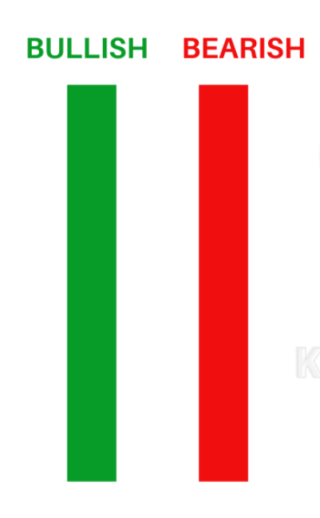
- Marubozus (Meaning: Dominance) are considered extremely powerful candles
- A bullish Marubozu indicates that the price dominantly kept rising without falling down.
- A bearish Marubozu indicates that the price dominantly kept falling without pushing upward.

18. IN TRADING,
Never underestimate what can be built in a year, or what can be destroyed in a day. A moment of IMPATIENCE can ruin all the hard work that you have put in.
19. Types of technical indicators

Volume Indicator
- Money Flow Index
- On-balance Volume
- VWAP
Trend Indicator
- Moving averages
- MACD
- PARABOLIC SAR

Volatility Indicator
- Bollinger bands
- Donchian channel
- ATR
Momentum Indicator
- Relative Strength Index
- ADX

20. How to deal with TRADING FATIGUE
- Have a break. Taking some time off from trading can help you in coming back stronger.
- Consider taking part in new activities other than trading.
- Optimize your trading routine. Reduce the working hours if you’re constantly overburdened.

